CHARITABLE COLLECTIONS

POLICY

2019 – 2024

No. | Table of Contents | Page Number
 | Introduction | 3
2. | Policy Objectives | 3
3. | Street Collections | 4
 | - Introduction  - General principles  - Application process  - Displays and Advertising  - Carnivals  - Regulations  - Application refusal  - Appeals  - Enforcement  - Direct Debit Collections | 4-6
4. | House to House Collections | 7
 | - Introduction  - General principles  - Application process  - Regulations  - Grounds of refusal  - Right of Appeal  - Complaints | 7-9
5. | Equality Statement | 9
6. | Comments and Complaints | 10
7. | Monitoring and Review | 10
8. | Sharing of Information | 10
Appendix 1 | Regulations made by the Council with regard to Street Collections | 11 - 14
Appendix 2 | Institute of Fundraising (IoF) Agreement | 15 – 22
Appendix 3 | Regulations made by the Council with regard to House to House Collections | 23 - 25

- Introduction

1.1 East Staffordshire Borough Council is responsible for licensing charitable collections in the Borough.

1.2 Charitable collections fall into two categories:

  - House to House Collections for money or property and

  - Street Collections which include collections of cash or the sale of articles in the street.

1.3 The licensing of Charitable Collections is regulated by two separate Acts of Parliament:

  - The ‘Police, Factories, etc (Miscellaneous Provisions) Act 1916 as amended by the Local Government Act 1972 which regulates collections of money or sales of articles for charitable purposes in streets and public places and

  - The ‘House to House Collections Act 1939’, which regulates collections of money or other articles made by means of going from house to house.

1.4 Both Acts give Councils powers to write regulations and policies to control charitable collections.

1.5 This document forms the Councils Charitable Collections Policy that will apply to Street Collections and House to House Collection activities in the East Staffordshire area to ensure consistency in decision making.

1.6 The aim of the policy is to provide detailed guidance on the application of the law relating to Charitable Collections, provide a clear statement of the requirements that charitable organisations, promoters and collectors must meet before, during and after collections take place.

- Policy Objectives

  - The purpose of the policy is to:

- To protect the interests of both public donors and the beneficiaries
- Facilitate well organised collections by bona fide charitable institutions and to ensure that good standards are met
- Prevent unlicensed collections from taking place
- Provide guidance on the application of the law relating to charitable collections
- Detail the requirements that charitable organisations, promoters and collectors must meet before, during and after collections take place.

  - The policy is designed to ensure that:

- There is transparency, consistency and fairness in determining applications

- Accommodating all eligible requests, subject to capacity, and bearing in mind that certain days and locations are especially sought after

- Providing equality of opportunity for prospective collectors

- Avoid nuisance being caused to the public

- Setting fair maximum limits for applicants

- Achieving a fair balance between local and national causes

STREET COLLECTIONS

3.1 Introduction

3.2 East Staffordshire Borough Council regulates charitable collections in the street. Any collection, whether cash, direct debit pledges or property, undertaken in any street or public place, should be licensed by the relevant Local Authority in accordance with the Police, Factories, etc (Miscellaneous Provisions) Act 1916 as amended by the Local Government Act 1972.

3.3 Charitable collections in stores, supermarkets or on private land do not require a Street Collection permit from the Council. Collections will however require the permission from the store or private land owner to allow the collection to take place.

3.4 The Council does not issue permits to collect in any of the following shopping centres and permission must be granted from the Shopping Centre Manager.

- Coopers Square
- Burton Place
- The Octagon Shopping Centre.

3.5 Anyone wishing to make a collection in any of the above must contact the Shopping Centre Manager directly.

3.6 Street Collections are covered by regulations made under the Police, Factories, etc (Miscellaneous Provisions) Act 1916 as amended by the Local Government Act 1972. The purpose of the Regulation is to ensure that collections are controlled to prevent nuisance to members of the public, and to provide an audit trail with regard to the allocation of funds. The regulations are attached at Appendix 1.

3.7 General Principles

3.8 Charities must be registered with the Charity Commission or be a charitable organisation based within East Staffordshire.

3.9 Applications will be granted on a first come first served basis. No guarantee can be given that an organisation’s preferred collection date will be available or be allocated to that organisation.

3.10 No more than 3 collections per charity per calendar year will be allowed in the Borough of East Staffordshire.

3.11 Only one Street Collection permit will be issued on any one given day (one in Burton and one in Uttoxeter).

3.12 Collections can take place on any day of the week including Public Holidays

3.13 Application Process

3.14 An application for a Street Collection Permit must be made to the Council in writing on the relevant application form no later than one month before the proposed collection date. The application period of one month may be reduced if there are special reasons for doing so.

3.15 The application form must be fully completed and accompanied by any required information.

3.16 The application form must include the location from which the organisation wishes to collect, the date and time of the collection and the number of collectors to be used.

3.17 Where the applicant is not a member of the registered charity a letter of authority is required and this must be submitted with the application.

3.18 Failure to provide the necessary information may result in an application being delayed or refused.

3.19 Applications will be considered by the Licensing Authority on their respective merits and the Licensing Authority will either:

  - Issue a permit specifying the requested date / location; or
  - Refuse to issue a permit

3.20 Within one month of the collection a financial return must be completed and returned to the Council in accordance with the regulations. The returns form must detail the amount received and expenses incurred in connection with such a collection.

3.21 A maximum of 10% of the total collection may be deducted for expenses. If the return is not received, no further collections will be offered for a period of 6 months from the date of the last collection.

3.22

Displays and Advertising

The use of tables, stalls, trailers, vehicles or other displays or advertising in connection with a Street Collection will not be permitted unless the collection is part of a separate promotion or activity approved by the Licensing Department. The use of animals will only be permitted with the express consent of the Licensing Authority and with the necessary Public Liability Insurance in place.

3.23 Carnivals

For collections involving a carnival, bed push, standing display, vehicles etc, Staffordshire Police and Staffordshire County Council will need to be consulted.

3.

24

Regulations

Applicants for permits and those who have been granted a permit shall comply with the Council’s Regulations. Any person who acts in contravention of these Regulations is guilty of an offence which on conviction is punishable by a fine not exceeding Level One (currently £200).

3.25 Application refusal

A Street Collection can be refused for a period of 6 months from the date of the last collection if the charity has not sent in a statement of accounts from a previous collection, or they are being investigated by the Charity Commission or they have already had the maximum amount of collections allowed in East Staffordshire.

3.26 Appeals

There is no formal right of appeal against any decision made by the Council to grant or refuse an application for a Street Collection permit. However, in the interests of fairness if an organisation wishes to lodge a request for a decision to be reviewed then the matter should be put in writing to the Head of Regulatory Services, East Staffordshire Borough Council, PO Box 8045, Burton upon Trent, Staffordshire, DE14 1LS who will review the decision.

3.27 Enforcement

Failure to comply with legislative requirements is an offence. In determining what enforcement action to pursue in respect of an offence, decisions will be made in line with the Councils Corporate Enforcement Policy and any relevant national guidance.

3.28 Direct Debit Collections

3.29 The activities of direct debit mandate collectors, face to face collectors, are not regulated by the law, and are not therefore subject to any licensing provision (clipboard collectors or chuggers).

3.30 The Council has entered into a site agreement with the Institute of Fundraising (IoF). The purpose and spirit of the site agreement is to facilitate responsible face to face fundraising and provide a balance between the duty of charities and not for profit organisations to fundraise and the rights of the public to go about their business without the impression of undue inconvenience. A copy of the Council’s agreement with the Institute of Fundraising (IoF) is included as Appendix 2.

3.31 Organisations can make up to 2 daily visits per week, however only one charity will be present on any site on any day.

3.32 As part of the return, Direct Debit companies must inform the Council how many sign-ups were received.

3.33 A maximum of 10% is allowed to be deducted for expenses.

4.0 HOUSE TO HOUSE COLLECTIONS

4.1 Introduction

4.2 Public Charitable Collections conducted on a house-to-house basis are currently regulated by the House to House Collections Act 1939 and the House to House Collections Regulations 1947.

4.3 No collection for a charitable purpose may be made unless the provisions of the Act and the Regulations are complied with; otherwise a criminal offence is committed. If any person or organisation promotes a charitable collection then they must hold a licence to do so.

4.4 Collections generally take place from door to door or from one public house to another and can include property or cash.

4.5 The Secretary of State for

Digital, Culture, Media and Sport is responsible for the National Exemption Order Scheme. National Exemption Orders are generally available to charities who have undertaken a high number of collections across local authority licensing areas for the two preceding years. In these cases a House to House Collection licence will not be required from a local authority. Most will notify the authority (out of courtesy) stating the date and places they will be collecting.

4.6 Most of the smaller, and particularly local groups and organisations need a licence before they can collect money (or articles which they intend to sell later such as unwanted clothing), from door to door.

4.7 If the Chief Constable for the Police Area comprising a locality in which a collection for a charitable purpose is being, or is proposed to be made, is satisfied that the purpose is local in character and that the collection is likely to be completed within a short period(less than 14 days), he may grant to the person who appears to him to be principally concerned in the promotion of the collection a Certificate in the prescribed form; and where a Certificate is so granted, a Licence from the Licensing Authority is not required, and the provisions of the Regulations shall not apply to a collection made in conformity with such Certificate. For collections that are to take place for 14 days or more then the application should be made to the Local Authority unless a Home Office exemption is in place. A statement of accounts from the collection must be returned on the prescribed form provided. Failure to return the form could result in future applications being refused.

4.8 General Principles

4.9 Charities must be registered with the Charity Commission or be a charitable organisation based within East Staffordshire or providing support to residents of East Staffordshire.

4.10 Applications must be on behalf of charitable organisations. Applications from private companies for commercial purposes will not be considered.

4.11 A House to House Collection licence can be granted for any period up to one year.

4.12 No collections shall be made in a manner likely to inconvenience or annoy any person.

4.13 No collector shall pester any person to the annoyance of such as person.

4.14

No more than 20% may be deducted from the total collection amount for expenses.

4.15 Application Procedure

4.16 Applications are to be made in writing, on the relevant form, no later than one month before the collection is due to take place, this period may be reduced if the Council are satisfied there are special reasons for doing so.

4.17 Applications will be dealt with on a first come first served basis.

4.18 Failure to provide the necessary information may result in an application being delayed or refused.

4.19 Applicants must supply information relating to:

- Whether it is a registered charity (please state number), and the objectives of the charitable cause as supplied to the Charity Commission
- A statement of the organisations aims as detailed in any literature
- Relevant accounts and financial statements of the organisation
- A written agreement between the applicant and the organisation
- A declaration of any previous refusals for House to House Collections

4.20 Applicants must also provide details of the following:

  - How much the charity will receive as part of the collection
  - The percentage of the cost of running the collection

4.21 If the organisation has collected before a clear set of returns must be supplied.

4.
22

Once a licence has been granted, applicants will be issued with a certificate for the information of The Stationery Office, to enable them to obtain prescribed certificates of authority and badges required. This certificate must be taken or sent to The Stationery Office from which the prescribed certificates of authority and badges may be purchased (applicants will need to supply these to each of its collectors). It is an offence for any collector to collect without having in possession the required signed authority and badge.

4.23 Following the collection, a form of statement must be returned to the Council within one month, giving an account of the monies raised.

4.24 Regulations

4.25

House to House Collection licenses issued are subject to the Regulations which are attached to this policy at Appendix Three.

4.26 Any person who acts in contravention of any of the foregoing regulations shall be liable on summary conviction to a fine not exceeding Level 1 on the Standard Scale, (currently £200).

4.27 Grounds of refusal

4.28 One of the key grounds for refusal would be where the total amount likely to be applied for charitable purpose as a result of the collection, is inadequate in proportion to the value of the proceeds likely to be received. So, for instance, where an applicant intends to claim a fair proportion of the proceeds of the collection for expenses, a licence could be refused. There is no statutory guidance to local authorities on what would be a reasonable amount for expenses.

4.29 East Staffordshire Borough Council allows a maximum of 20% which is considered a reasonable amount to be deducted for expenses.

4.30 Right of Appeal

4.31 There is a right of appeal to the Minister for the Cabinet Office against the decision of the Council to refuse an organisation a licence to hold a House to House Collection or to revoke such a licence.

4.

32 An appeal must be lodged within 14 days of the date on which the notice of refusal is issued.

4.33 Complaints

4.34 If the Council receives any complaints regarding charities/organisations carrying out collections an investigation will be carried out and may affect any future applications.

4.35 Anyone acting as a collector where there is not a licensed promoter also commits a criminal offence. Offences are punishable by penalties ranging from a minimum fine of £200 up to six months imprisonment and a fine of up to £1,000.

5.0 Equality Statement

5.1 We believe in equality of opportunity for all people. When conducting compliance checks or making enforcement decisions we will ensure that there is no discrimination against any individual(s) on the grounds of age, race, colour, ethnic or national origin, nationality, religion and belief, gender, marital status, employment status, disability, sexual orientation, social class, responsibility for children or dependents, trade union membership, unrelated criminal convictions or any ground that cannot be justified.

5.2 The Council will ensure that all its services, facilities and resources are accessible and responsive to the people and communities of the Borough.

5.3 We understand that some members of the community may have specific difficulties, which will need extra advice and assistance. Careful explanation will be given and if necessary the services of an interpreter may be used. We will work in accordance with the Council’s Single Equality Scheme.

5.4 If requested, we will arrange for appropriate documents to be translated into alternative formats or languages and we will provide practical help for people with impaired hearing, vision or other impairment.

6.0 Comments and Complaints

6.1 We encourage comments on the content and application of this Policy; any such comments will be used to assist in improving how we deliver our enforcement activities.

6.2 Where a person is concerned that any enforcement action taken by us is not in accordance with this Policy they can complain. Any complaint will be dealt with in line with the Councils Complaint Procedures. In the first instance the complaint will be passed to the Manager of the service to which it relates for investigation.

6.3 Where the Council’s Complaints Procedure has been exhausted and the person remains aggrieved they may ask the Local Government Ombudsman to look into the matter.

7.0 Monitoring and Review

7.1 We will monitor our performance against the requirements of this Policy and publish our findings on annual basis.

7.2 We will use these findings, along with any changes in law and practice, to assist in the periodic review of the Policy.

8.0 Sharing of Information

8.1 The Council will share with other enforcement bodies information supplied by applicants, or acquired in the course of exercising licensing functions, where it is lawful to do so. In particular, personal information will only be disclosed in accordance with the Data Protection Act 1998. This may include requests from the Audit Commission or other regulatory agencies where this is necessary for the detection or prevention of crime or required by law or in connection with legal proceedings.

APPENDIX 1

E A S T S T A F F O R D S H I R E B O R O U G H C O U N C I L

REGULATIONS MADE BY THE COUNCIL WITH REGARD TO STREET COLLECTIONS

1. In these Regulations, unless the context otherwise requires -

collection means a collection of money, direct debit pledges or personal details to be used at a later date or a sale of articles for the benefit of charitable or other purposes and the word 'collector' shall be construed accordingly;

promoter means a person who causes others to act as collectors;

the Licensing Authority means the East Staffordshire Borough Council;

permit means a permit for a collection;

contributor means a person who contributes to a collection and includes a purchaser of articles for sale for the benefit of charitable or other purposes;

collection box means a box or other receptacle for the reception of money from contributors.

2. No collection, other than a collection taken at a meeting in the open air shall be made in any street or public place within the Borough of East Staffordshire unless a promoter shall have obtained from the Licensing Authority a permit.

3. Application for a permit shall be made in writing not later than one month before the date on which it is proposed to make the collection.

Provided that the Licensing Authority may reduce the period of one month if satisfied that there are special reasons for so doing.

4. No collection shall be made except upon the day stated in the permit.

5. The Licensing Authority may, in granting a permit, limit the collection to such streets or public places or such parts thereof as it thinks fit.

6. (a) No person may assist or take part in any collection without the written authority of a promoter.

(b) Any person authorised under paragraph (a) above shall produce such written authority forthwith for inspection on being requested to do so by a duly authorised officer of the Licensing Authority or any police constable.

7. No collection shall be made in any part of the carriage way of any street which has a footway.

Provided that the Licensing Authority may, if it thinks fit, allow a collection to take place on the said carriage way where such collection has been authorised to be held in connection with a procession.

8. No Collection shall be made in a manner likely to inconvenience or annoy any person.

9. No collector shall importune any person to the annoyance of such person.

10. While collecting -

(a) a collector shall remain stationary; and

(b) a collector or two collectors together shall not be nearer to another collector than 25 metres.

Provided that the Licensing Authority may, if it thinks fit, waive the requirements of this Regulation in respect of a collection which has been authorised to be held in connection with a procession.

11. No promoter, collector or person who is otherwise connected with a collection shall permit a person under the age of 16 years to act as a collector.

12 Where cash collections are taking place:

(a) Every collector shall carry a collecting box.

(b) All collecting boxes shall be numbered consecutively and shall be securely closed and sealed in such a way as to prevent them being opened without the seal being broken.

(c) All money received by a collector from contributors shall immediately be placed in a collecting box.

(d) Every collector shall deliver, unopened, all collecting boxes in his possession to a promoter.

13. A collector shall not carry or use any collecting box, receptacle or tray which does not bear displayed prominently thereon the name of the charity or fund which is to benefit nor any collecting box which is duly numbered.

14. (a) Subject to paragraph (b) below a collecting box shall be opened in the presence of a promoter and another responsible person.

(b) Where a collecting box is delivered, unopened, to a bank, it may be opened by an official of the bank.

(c) As soon as a collecting box has been opened, the person opening it shall count the contents and shall enter the amount with the number of the collecting box on a list which shall be certified by that person.

15. (a) No payment shall be made to a collector.

(b) No payment shall be made out of the proceeds of a collection, either directly or indirectly, to any other person connected with the promotion or conduct of such collection for, or in respect of, services connected therewith, except such payments as may have been approved by the Licensing Authority.

16. (a) Within one month after the date of any collection the person to whom a permit has been granted shall forward to the Licensing Authority -

- A statement in the form set out in the Schedule to the Street Collection Regulations in the Borough or in a form to the like
- effect, showing the amount/pledges received and the expenses and payments incurred in connection with such collection, and certified by that person and a qualified accountant;

(ii) a list of the collectors;

(iii) a list of the amounts contained in each collecting box;

and shall, if required by the Licensing Authority, satisfy it as to the proper application of the proceeds of the collection.

(b) The said person shall also, within the same period, at the expense of that person and after a qualified accountant has given his certificate under paragraph (a)(i) above, publish in such newspaper or newspapers as the Licensing Authority may direct a statement showing the name of the person to whom the permit has been granted, the area to which the permit relates, the name of the charity or fund to benefit, the date of the collection, the amount collected, and the amount of the expenses and payments incurred in connection with such collection.

(c) The Licensing Authority may, if satisfied there are special reasons for so doing extend the period of one month referred to in paragraph (a) above.

(d) For the purposes of this Regulation 'a qualified accountant' means a member of one or more of the following bodies:

the Institute of Chartered Accountants in England and Wales;
the Institute of Chartered Accountants of Scotland;
the Association of Certified Accountants;
the Institute of Chartered Accountants in Ireland.

(e) If a collection results in a sum of £500 or less being collected the Licensing Authority may if it thinks fit waive the requirements in paragraph (a), sub-paragraph (i) and paragraph (b) of this Regulation, that the statement of accounts shall be certified by a qualified accountant and waive the need to publish a notice in a newspaper as the Licensing Authority may direct a statement showing the name of the person to whom the permit has been granted, the area to which the permit relates, the name of the charity or fund to benefit, the date of the collection, the amount collected, and the amount of the expenses and payments and substitute therefore a certificate signed by an independent person acceptable to the Licensing Authority.

17. These Regulations shall not apply -

(a) in respect of a collection taken at a meeting in the open air; or

(b) to the selling of articles in any street or public place when the articles are sold in the ordinary course of trade.

* 18. Any person who acts in contravention of any of the foregoing regulations shall be liable on summary conviction to a fine not exceeding twenty five pounds for a first or subsequent offence.

* Your attention is drawn to the increase in penalties effected by the
Criminal Law Act 1977.

APPENDIX 2 – Institute of Fundraising (IoF) Agreement

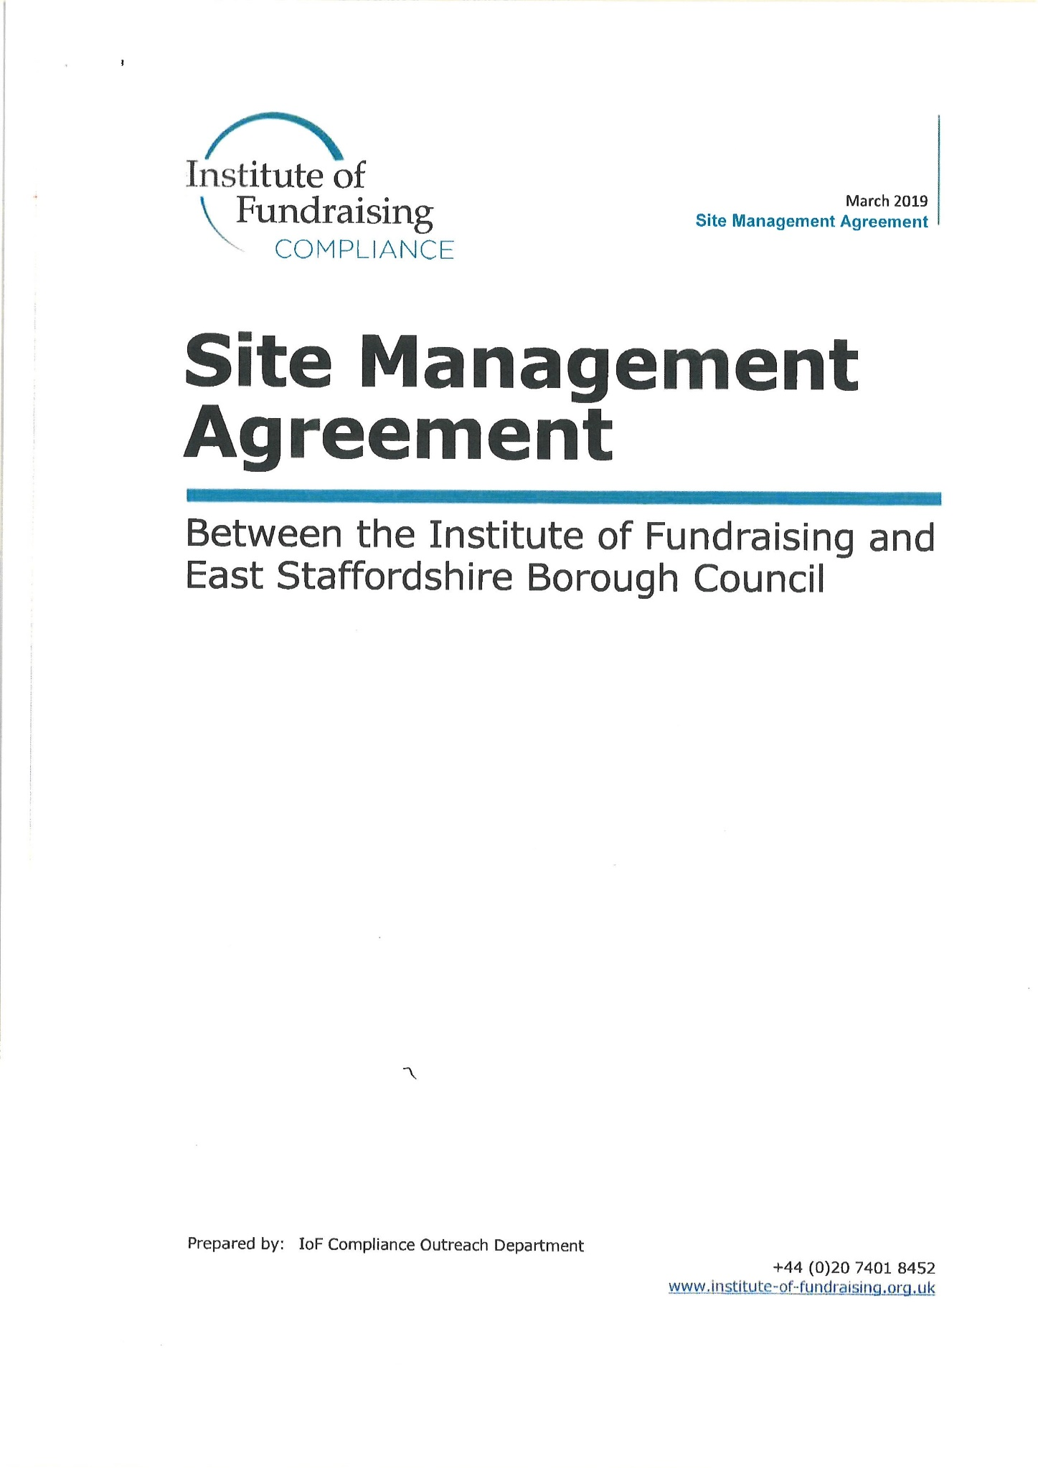

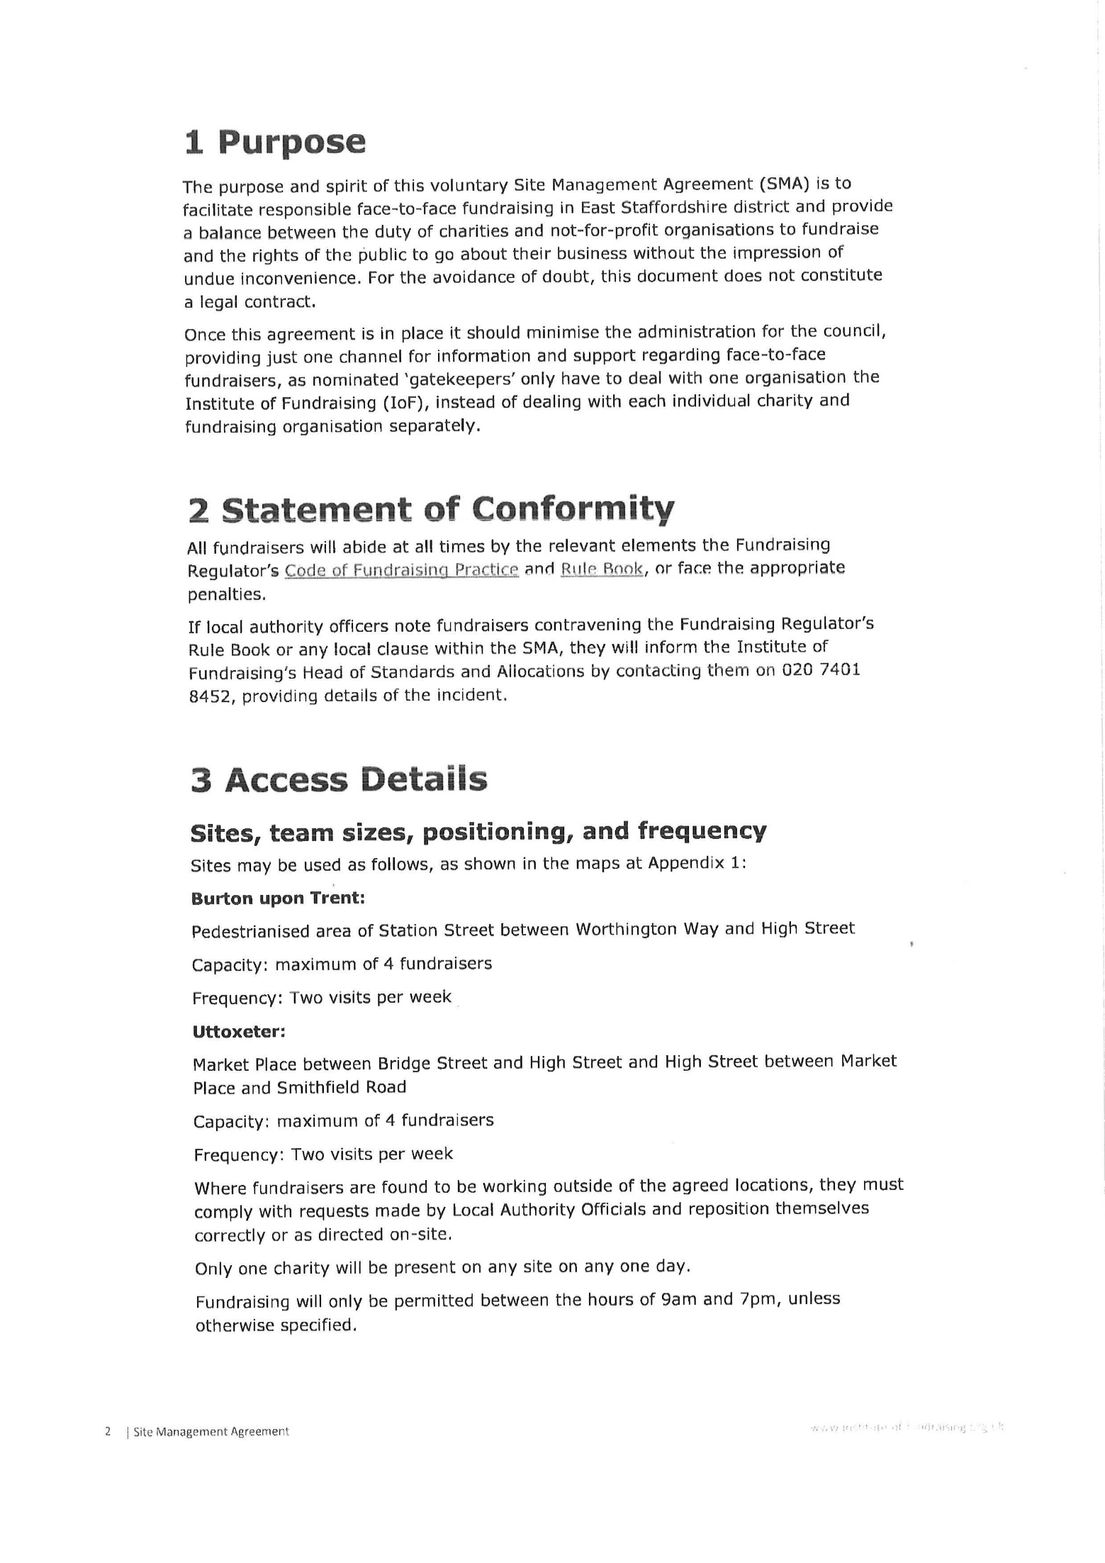

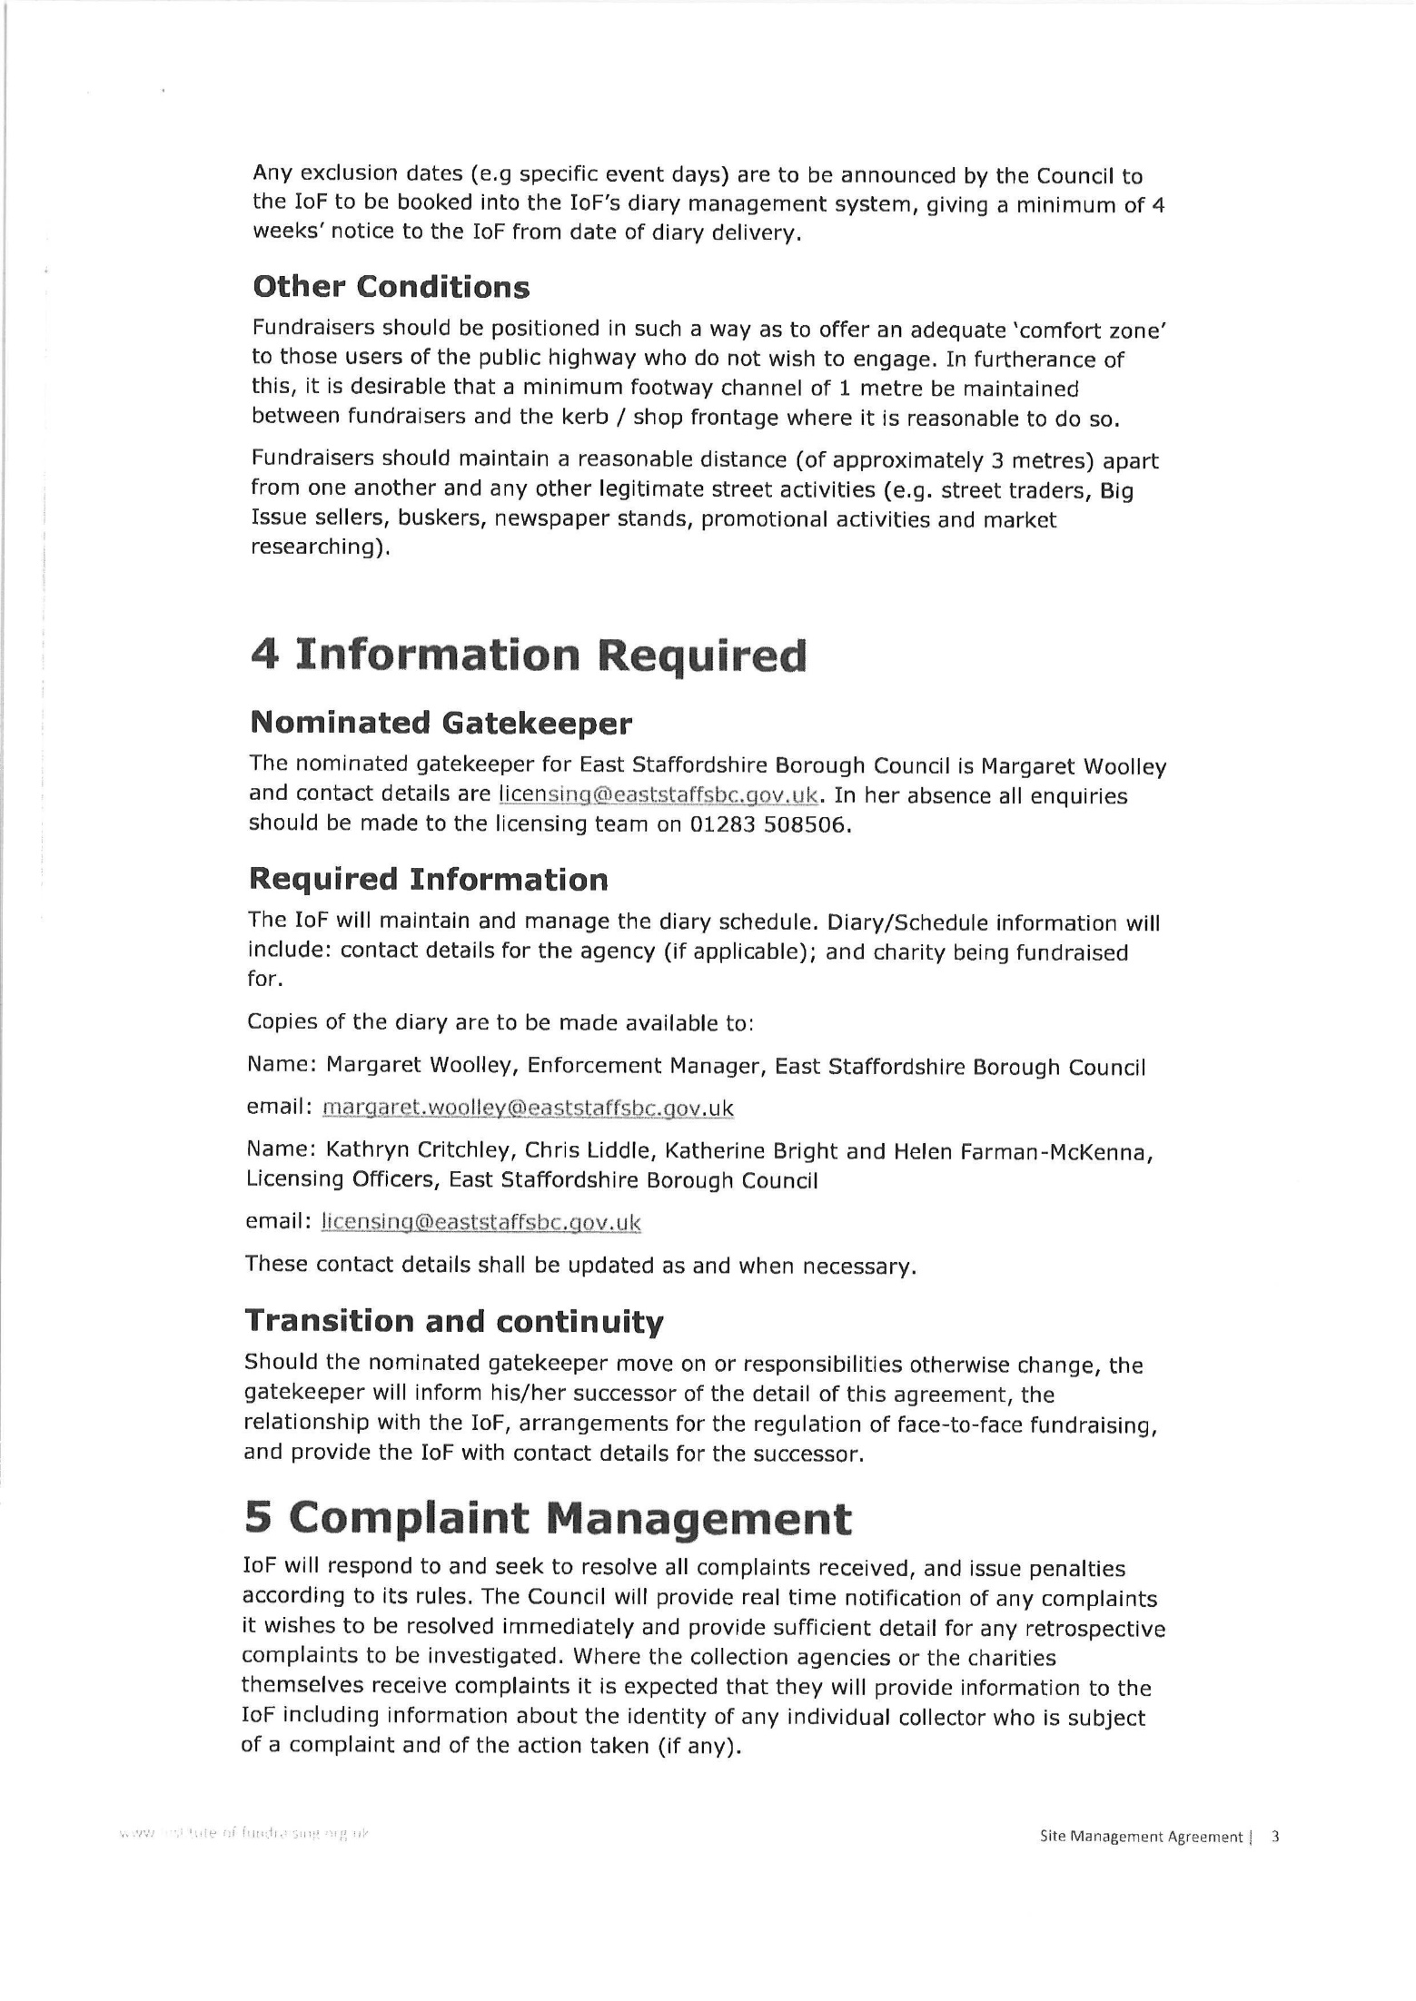
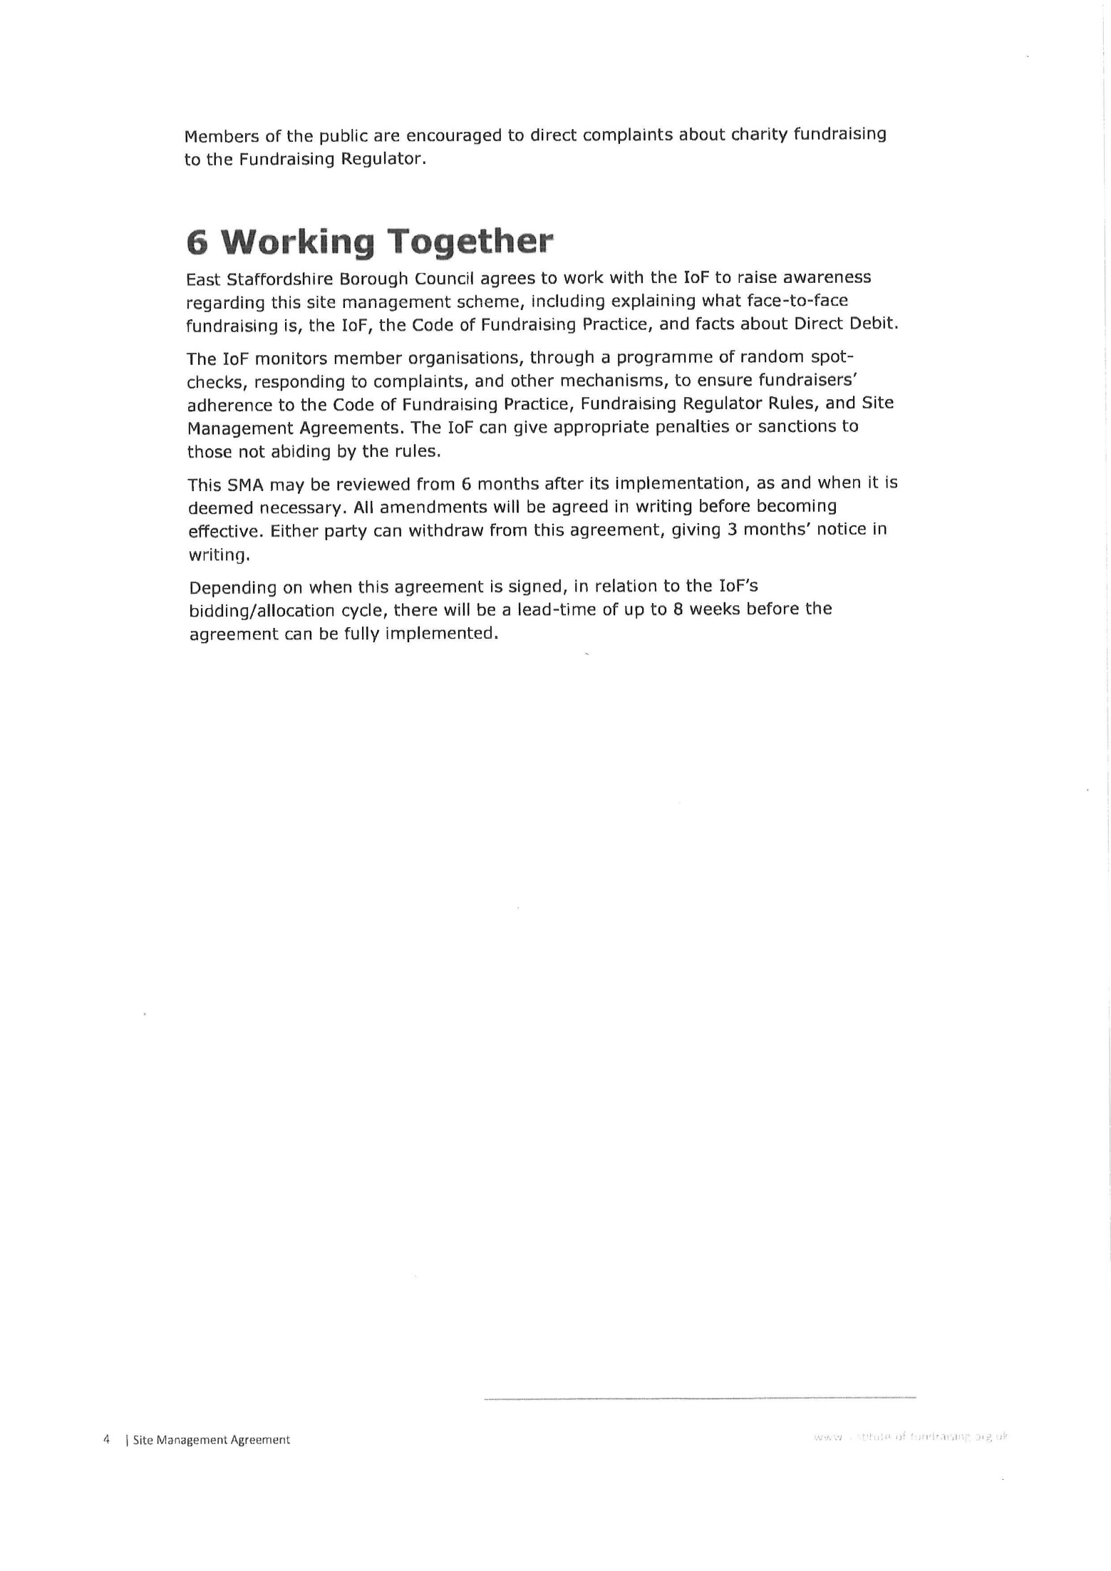

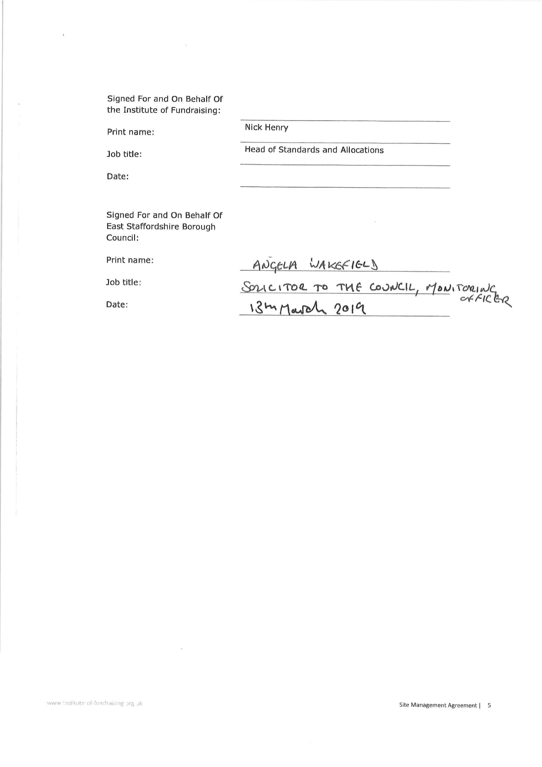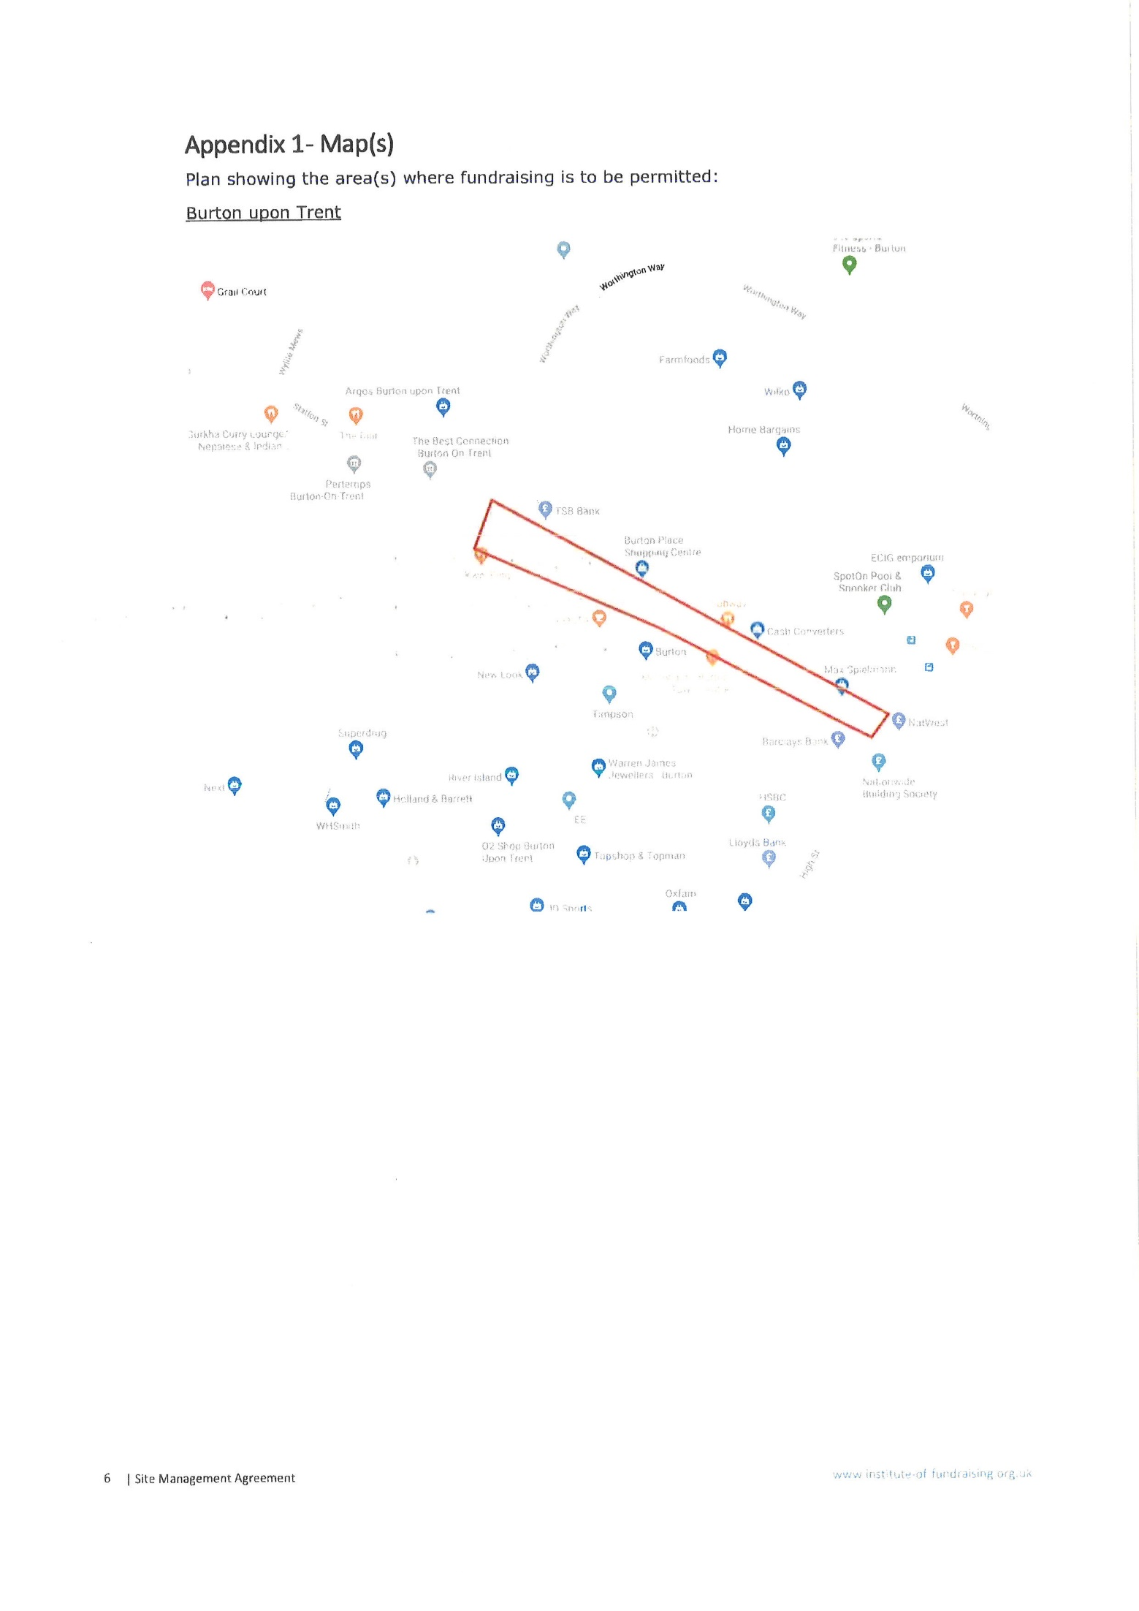

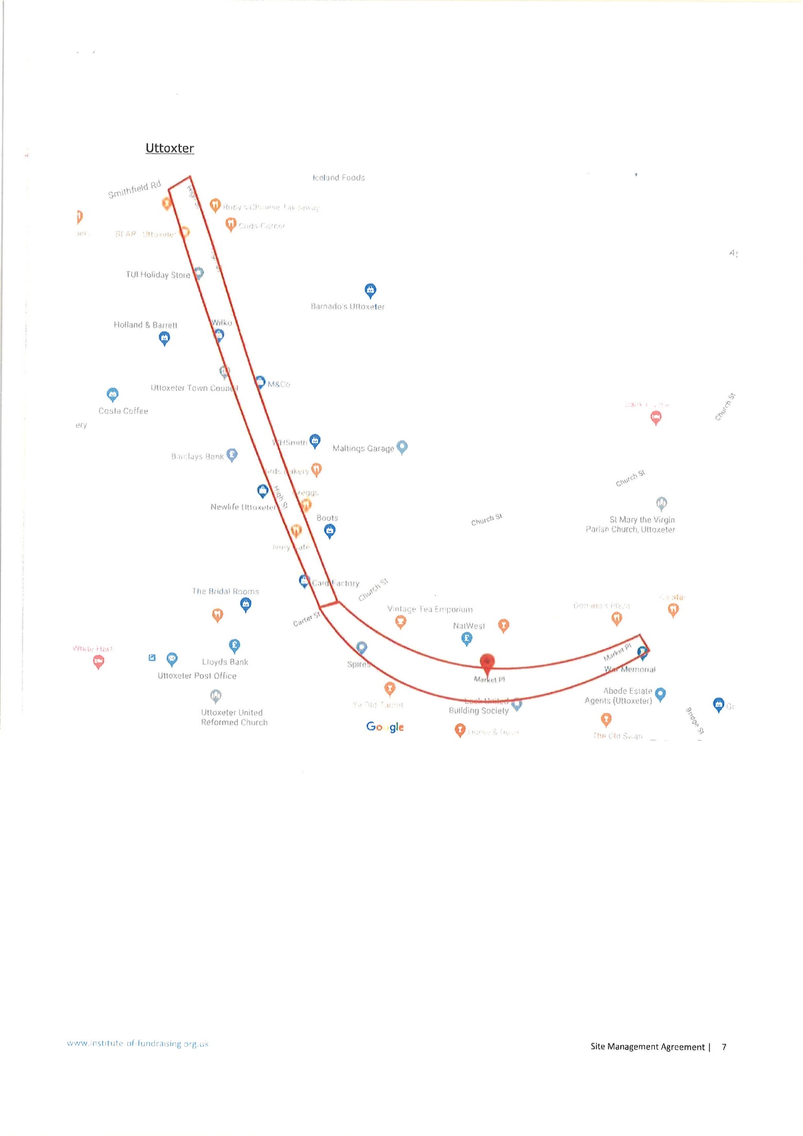
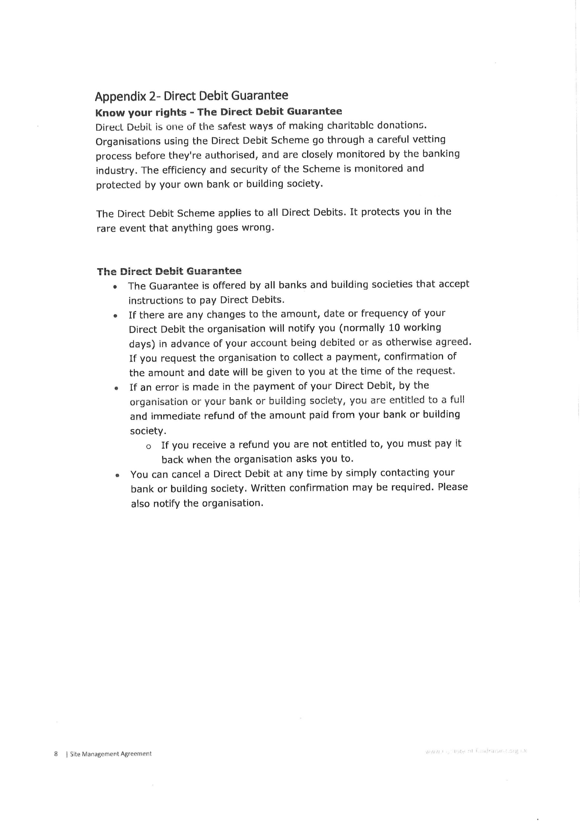
APPENDIX 3

E A S T S T A F F O R D S H I R E B O R O U G H C O U N C I L

HOUSE TO HOUSE COLLECTIONS REGULATIONS

1. In these regulations, unless the context otherwise requires:

'The Act' means the House to House Collections Act 1939;

'Chief Promoter' in relation to a collection, means a person to whom a licence has been granted authorising him to promote that collection or in respect of whom an order has been made directing that he shall be exempt from the provisions of Subsection (2) or Section 1 of the Act as respects that collection;

'collecting box' means a box or other receptacle for monetary contributions, securely closed and sealed in such a way that it cannot be opened without breaking a seal;

'licence' means a licence granted by the Local Authority under section 2 of the Act;

'order' means an order made by the Secretary of State under Section 3 of the Act;

'prescribed badge' means a badge in the form set out in the fourth Schedule to these regulations;

'receipt book' means a book of detachable forms of receipt consecutively numbered with counterfoils or duplicates correspondingly numbered.

2. A mark shall for the purpose of these regulations be deemed to have been made on a collecting box if it is made on a wrapper securely gummed to the collecting box.

3. An application for a licence shall be made on the appropriate form not later than the first day of the month preceding that in which it is proposed to commence the collections:

Provided that the Licensing Authority may reduce this period if satisfied that there are special reasons for doing so.

4. Every Promoter of a collection shall exercise all due diligence:

a) to secure that persons authorised to act as collectors for the purposes of the collection are fit and proper persons; and

b) to secure compliance on the part of persons so authorised with the provisions of these regulations.

5. No Promoter of a collection shall permit any person to act as a collector, unless he has issued or caused to be issued to that person:

- a prescribed Certificate of Authority duly completed (except as regards the signature of the collector) and signed by or on behalf of the Chief Promoter of the collection;

b) a prescribed badge, having inserted therein or annexed thereto a general indication of the purposes of the collection; and

c) if money is to be collected, a collecting box or receipt book marked with a clear indication of the purpose of the collection and a distinguishing number, which indication and number shall, in the case of a receipt book, also be marked on every receipt contained therein in addition to the consecutive number of the receipt.

6. Every Promoter of a collection shall exercise all due diligence to secure:

a) that no prescribed Certificate of Authority, prescribed badge, collecting box or receipt book is issued, unless the name and address of the collector to whom it is issued have been entered on a list showing in respect of any collecting box or receipt book the distinguishing number thereof; and

b) that every prescribed Certificate of Authority, prescribed badge, collecting box or receipt book issued by him or on his behalf is returned when the collection is completed or when for any other reason a collector ceases to act as such.

7. In the case of a collection in respect of which a licence has been granted:

a) every prescribed Certificate of Authority shall be given on a form obtained from Her Majesty's Stationery Office, and every prescribed badge shall be so obtained; and

b) every prescribed Certificate of Authority shall be authenticated, and the general indication on every prescribed badge of the purpose of the collection shall be inserted therein and annexed thereto, in a manner approved by the Licensing Authority.

8. Every collector shall:

a) sign his name on the prescribed Certificate of Authority issued to him and produce it on the demand of any Police Constable or of any occupant of a house visited by him for the purpose of collection;

b) sign his name on the prescribed badge issued to him and wear the badge prominently whenever he is engaged in collecting; and

c) keep such certificate and badge in his possession and return them to a Promoter of the collection on replacement thereof or when the collection is completed or at any other time on the demand of the Promoter of the collection.

9. No person under the age of 16 years shall act or be authorised to act as a collector of money.

10. No collector shall importune any person to the annoyance of such person, or remain in, or at the door of, any house if requested to leave by any occupant thereof.

11. Where a collector is collecting money by means of a collecting box, he shall not receive any contribution save by permitting the person from whom it is received to place it in a collecting box issued to him by a Promoter of the collection.

12. Every collector, to whom a collecting box or receipt book has been issued, shall:

a) when the collecting box is full or the receipt book is exhausted, or

b) upon the demand of a Promoter of the collection, or

c) when he does not desire to act as a collector, or

d) upon the completion of the collection,

return to a Promoter of the collection that collecting box with the seal unbroken or that receipt book with a sum equal to the total amount of the contributions (if any) entered therein.

13. a) subject as provided in paragraph 1 of this regulation, a collecting box when returned shall be examined by, and, if it contains money, be opened in the presence of, a Promoter of the collection and another responsible person;

b) where a collecting box is delivered unopened to a bank, it may be examined and opened by an official of the bank in the absence of a Promoter of the collection;

c) as soon as a collecting box has been opened, the contents shall be counted and the amount shall be entered with the distinguishing number of the collecting box on a list, which shall be certified by the persons making the examination;

d) every receipt book when returned and all sums received therewith shall be examined by a Promoter of the collection and another responsible person, and the amount of the contributions entered in the receipt book shall be checked with the money and entered with the distinguishing number of the receipt book on a list, which shall be certified by the persons making the examination.

14. The Chief Promoter of a collection in respect of which a licence has been granted shall furnish an account of the collection to the Licensing Authority on the form prescribed within one month of the expiry of the licence;

Provided that the Licensing Authority may extend the period within which an account is required to be furnished if satisfied there are special reasons for doing so.

15. The Chief Promoter of a collection shall exercise all due diligence to secure that all forms of prescribed Certificates of Authority and prescribed badges obtained by him for the purposes of the collection are destroyed when no longer required in connection with that collection or in connection with a further collection which he has been authorised to promote for the same purpose.

